**Ex. No:1 Roll No: 230701396**

**Date:31/07/2024 Name: M.Praveenraj**

**CREATION OF DATABASE AND DML OPERATIONS**

1. Create MY_EMPLOYEE table with the following structure

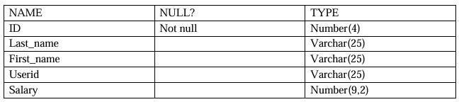

**create table MY_EMPLOYEE(ID NUMBER(4) NOT NULL, LAST_NAME VARCHAR(25), FIRST_NAME VARCHAR(25), SALARY NUMBER(9,2));**

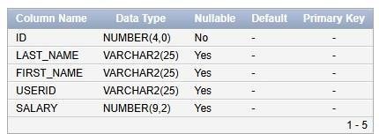

1. Add the first and second rows data to MY_EMPLOYEE table from the following sample data.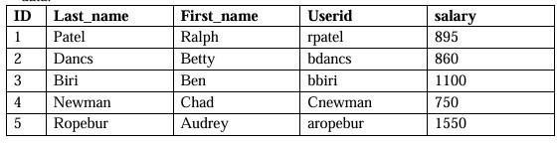

**insert into MY_EMPLOYEE(ID,LAST_NAME,FIRST_NAME,USERID,SALARY)**

**values (1,'Patel','Ralph','rpatel',895)**

**into MY_EMPLOYEE(ID,LAST_NAME,FIRST_NAME,USERID,SALARY) values**

**(2,'Dancs','Betty','bdancs',860)**

**into MY_EMPLOYEE(ID,LAST_NAME,FIRST_NAME,USERID,SALARY) values**

**(3,'Biri','Ben','bbiri',1100)**

**into MY_EMPLOYEE(ID,LAST_NAME,FIRST_NAME,USERID,SALARY) values**

**(4,'Newman','Chad','Cnewman',750)**

**into MY_EMPLOYEE(ID,LAST_NAME,FIRST_NAME,USERID,SALARY)**

**values (1,'Ropebur','Audrey','aropebur',1550);**

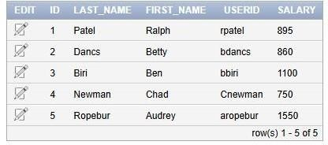

1. Display the table with values:

**SELECT * from MY_EMPLOYEE;**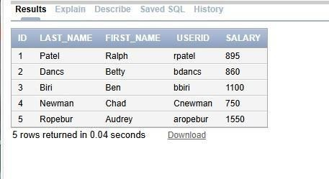

1. Populate the next two rows of data from the sample data. Concatenate the first letter of the first_name with the first seven characters of the last_name to produce Userid.

**insert into MY_EMPLOYEE(ID,LAST_NAME,FIRST_NAME,USERID,SALARY)**

**values (6,'Priyanga','Mohan','pmohan',7897)**

**into MY_EMPLOYEE(ID,LAST_NAME,FIRST_NAME,USERID,SALARY) values**

**(7,'Steve','Jack','jsteve',9879);**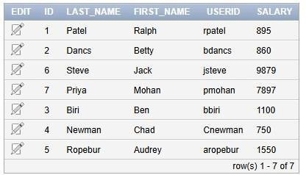

1. Delete Betty dancs from MY _EMPLOYEE table.

**delete from MY_EMPLOYEE where LAST_NAME='Dancs';**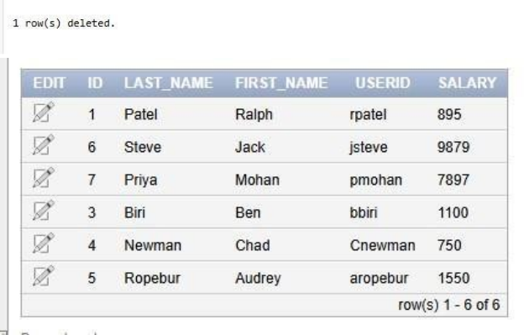

1. Empty the fourth row of the emp table.

**delete from MY_EMPLOYEE where ID=4;**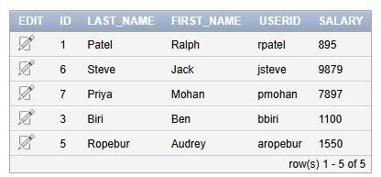

1. Make the data additions permanent.

**commit;**

1. Change the last name of employee 3 to Drexler.

**update MY_EMPLOYEE set LAST_NAME='Dexler' where ID=3;**

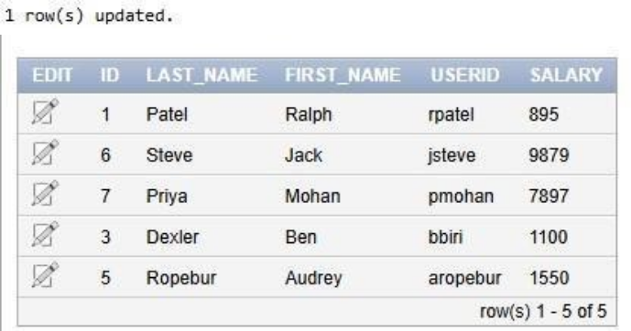

1. Change the salary to 1000 for all the employees with a salary less than 900.

**update MY_EMPLOYEE set SALARY=1000 where SALARY<900;**